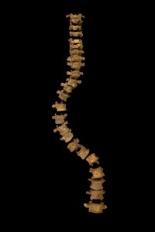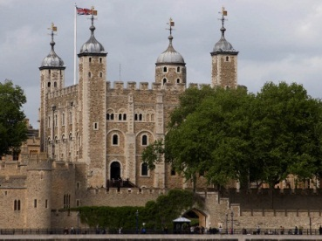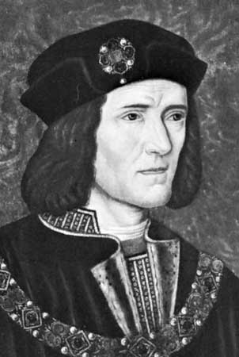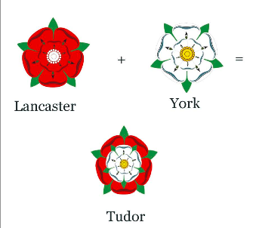

**Rebellion**

**A rebellion raised in October 1483 by the Duke of Buckingham, Richard's former ally, quickly collapsed. However, Buckingham's defection, along with his supporters, eroded Richard's power and support among the aristocracy and gentry.**

**Richard’s Rival**

**In August 1485, a member of the Lancaster family, Henry Tudor, crossed the English Channel from France. Henry wanted the English throne for his family and had an army to fight Richard.**

**Many of Richard’s friends deserted him, joining Henry. On 22nd August, in a field near Bosworth, Leicestershire, the two armies fought each other.**

**Appearance**

**William Shakespeare wrote that Richard III had a curved spine, withered arm and a limp. After the discovery of Richard’s body, it seems Shakespeare was correct about the spine but not the arm and limp.**

**How did Richard III become King?**

**Edward IV's reign was short-lived. He died in 1483 and his 12-year-old son Edward V became king.**

**Richard, brother of the king, was named protector and was to rule England until Edward was old enough to do so himself. However, instead of protecting the young king he put him and his brother in the Tower of London, and had himself crowned King Richard III.**

**As soon as he became King, Richard began executing his enemies without trial, and confiscating land. Many people suspected that he’d had his two nephews, the Princes in the Tower, murdered. As well as introducing bail, an affordable system of justice and laws written entirely in English, he also outlawed the passing of taxes without permission from the houses of Parliament.**

**Edward V was seen playing in the garden of the Tower of London, but later disappeared. It was widely believed that he and his brother were murdered by Richard III. In 1674, some workmen found the bones of two boys beneath a staircase in the tower - it is assumed that these were the bones of Edward V and his brother.**

**Name: Richard Plantagenet**

**Born: October 2nd, 1452.**

**Died: August 22, 1485**

**Married: Anne Neville**