BRAIN WARM-UP!

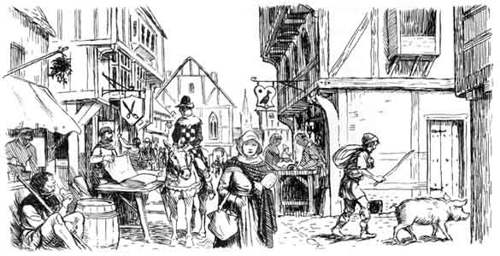
A Medieval village
Label two things that you think you can identify (you know what they are)
Circle 2-5 things that you could ask a question about

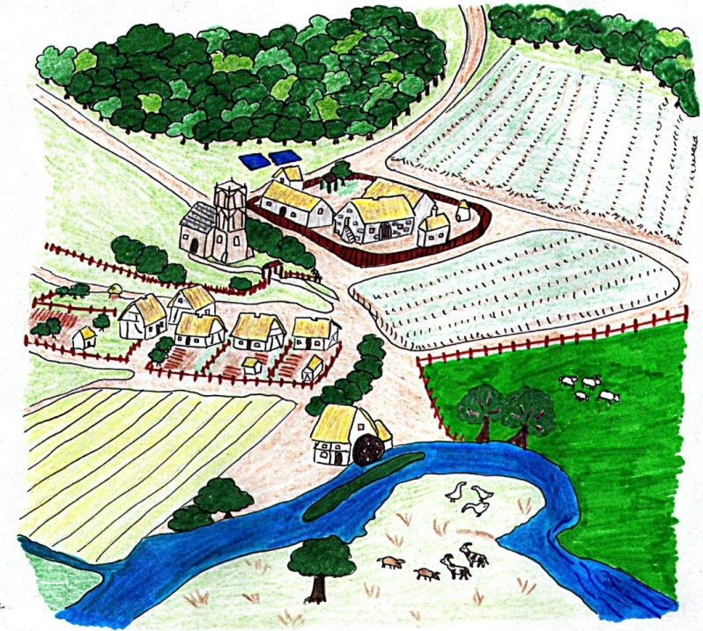
A Medieval town
Label two things that you think you can identify (you know what they are)
Circle 2-5 things that you could ask a question about
 | Your group’s guess | Answer from story
Your questions about the village
1.
2.
3.
4.
5.
Your questions about the town
1.
2.
3.
4.
5.

Group task

Medieval town vs village – story for reading aloud.
Edmund is a 12 year old peasant boy. He was born into a family of 7 in the manor of Walthingham. Edmund’s life, and the lives of his family members revolve around farming. His family have a small cottage of one room. The walls are made of mud and animal dung and the roof is made of straw. In the centre of the roof there is a hole for the smoke to escape. The family’s animals (two pigs and a cow) sleep at one end of the room, while the family sleep at the other.
Each morning, the family wake at dawn to begin working on their strip of land. In the village, all the farming land is divided up into narrow strips belonging to different families. Families may have more than one strip, spread out. People believe it is fairer this way – it means that there is more chance that every family will have some land that is fertile and some that is bare and stony. Everyone, even the children, chip in with the farming, planting, looking after and harvesting the crops.
Most of what the peasants produce goes to the lord of the manor. The peasants get to keep some of their produce though. They keep back just enough to feed themselves. In every small village there is a mill. This is the place where the peasants take their bags of grain to be ground up into flour. In Edmund’s village, the mill is powered by water, so it is located by the river. The peasants also have small gardens, where they might grow vegetables to sustain them – things like turnips, carrots and cabbages. If they want to keep animals, they graze them on the common land near the mill. This land belongs to everyone.
The lord of the manor not only owns these people’s land, he owns them too. They cannot leave the manor or even get married without his permission. Edmund and his family have little time off. On Sunday’s they go to church, the grandest building in the village, it is a break from the work, but they cannot understand what is going on because the services are conducted in Latin! The people know that it is important for them to pray and go to church though, and fear that if they do not they will go to hell. They also pay tax to the church for taking care of their souls.
Life is hard for Edmund’s family. The hardest time of year is winter. This is when there is least food around and when the crops aren’t growing. It is now that Edmund’s family have to survive on the vegetables they have put aside. In the middle of winter, they might slaughter one of their animals for meat. This is the only time they will eat meat, other than the fish they catch in the stream. To prepare themselves for the cold weather the peasants cover themselves in fat from their slaughtered beasts and sew themselves into their underclothes. By the end of the winter Edmund will stink and be infested with parasites, but at least this has stopped him dying of cold.
Life for the lord of the manor is of course much easier. He lives in a large house surrounded by a wall. In fact, there are many buildings within the walls of the manor, including a slaughter house and a storehouse. The lord also owns two fishponds. Not only is the manor his home, it also acts a bit like the village office. It is where the peasants come to pay their taxes and it is where the local court meets.
Every so often Edmund’s master – the lord – might allow him and his family to attend a fair in the local town. Going to the town is an exciting event for Edmund. The people there are different. They make their money from trading, not farming, and they are free. Edmund and his family walk 8 miles to the town. Even before they catch site of the town, they can smell it. So many people gathered together create a lot of waste, and there is no sewage or waste collection system. Approaching the town, Edmund and his family see first the high stone wall that surrounds it. Outside the wall, all the town’s rubbish is dumped. Pigs and dogs root around in the muck. But inside the walls, things are different – there are many grand buildings here – the homes of the great merchants, the monastery and the church or cathedral. The lanes are busy with people, especially on market day and on fair days, when people come from miles around to visit the town. They trade in cloth, in food and in other products. Some products, like spices and silk have been brought all the way from Asia on horseback. There are beggars, rich men and foreign traders, all mingling in the narrow lanes. The town does not smell good. Edmund sees animals being walked through the town. They are being taken to the butcher’s for slaughter. The butcher’s shop is the smelliest of all the buildings, apart from the tannery. The tanner is the man who turns animal skins into leather. This is done by keeping them in a pit of animal poo for many months.
Edmund notices that the shops and houses jut out on the first and second floor. This is because, in an overcrowded town, land is expensive. So people buy the smallest plot of land possible and make their house bigger by making it jut out above the ground. There are signs hanging from many of the shops. They usually display pictures instead of words. This is very useful to the majority of people, who cannot read or write. People come to recognise the pictures for the most popular shops. On the street corners are barrels full of water. These are essential. The houses are mostly wooden, and the water barrels are there in case of fire. There are usually a few drowned rats, or even cats, floating in the barrels. Down the side streets, things are pretty shabby. This is where the poor live – the labourers. Edmund and his family stay away from those narrow lanes for fear of having their pockets picked. Edmund loves the town – the noise and the excitement. But his parents find it too much, and at the end of the day are glad to get back to the village

