**What was Public Health like in Fourteenth Century London?**

1. A butcher in a pillory for selling rotting meat which is being burned in front of him.

2. Four female butchers throwing blood and offal in the streets.

3. Butchers using a segregated area to slaughter animals.

4. A wide street with two gutters and a narrow street with one.

5. Rakers removing horse dung from the streets.

6. Open sewers carrying waste to the river.

7. Anyone throwing water from a house was fined two shillings.

8. By the 1380’s there were 13 common privies in the city.

9. House owners living next to streams built their own private privies.

10. Some houses away from streams had private latrines built lined with stone, tiles & cement.

11. Butchers dumping waste in the Thames.

12. Wells for fetching water and a nearby cesspool for dumping waste.

13. Drunkenness on the street.

14. A man urinating on the street instead of using the common privy.

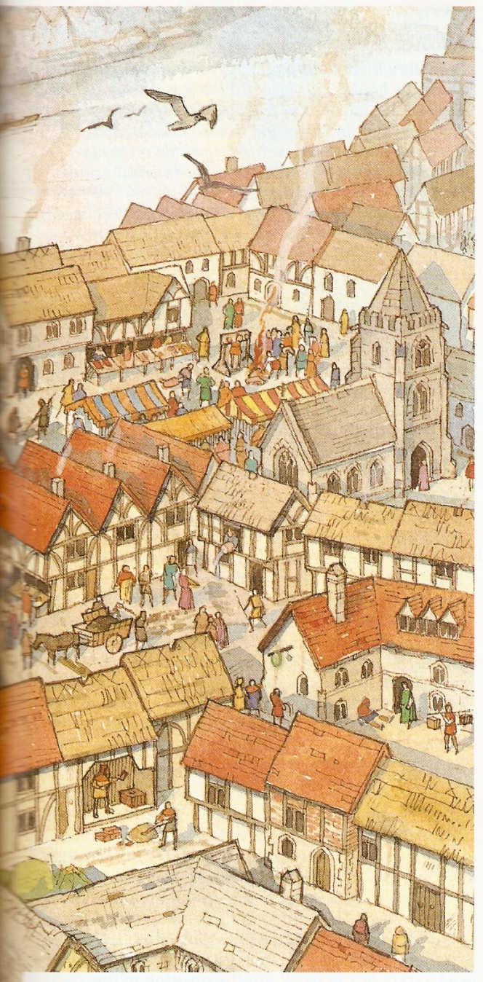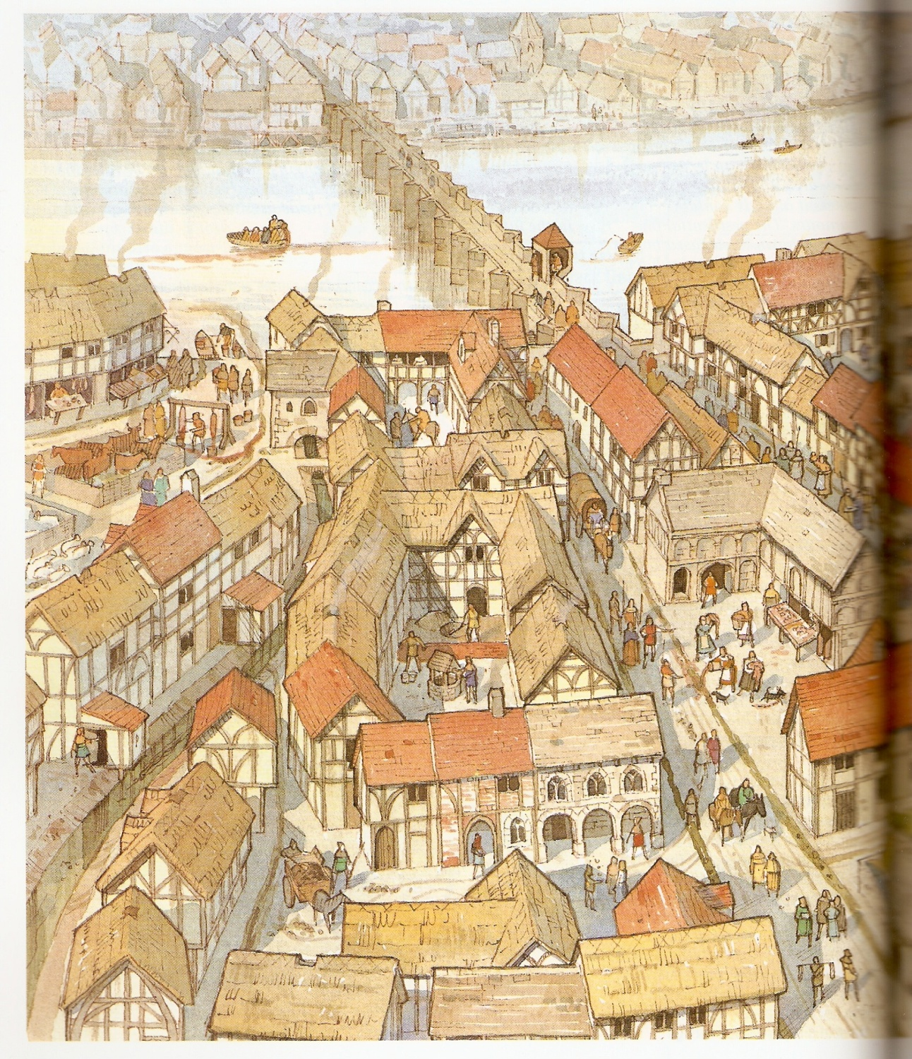

This illustration shows London in the Fourteenth Century. How many of the descriptions on the right can you spot?