The Battle of Agincourt 1415

Source C - *Jehan de Wavrin talks of Henrys reaction after the French attacked the baggage train.*

"When the King of England perceived them coming thus he caused it to be published that every one that had a prisoner should immediately kill him, which those who had any were unwilling to do, for they expected to get great ransoms for them. But when the King was informed of this he appointed a gentleman with two hundred archers whom he commanded to go through the host and kill all the prisoners, whoever they might be.

Source B - *Jehan de Wavrin was the son of a Flemish knight. His father and older brother fought with the French at the battle. Both were killed. The young de Wavrin observed the battle from the French lines and we join his account as the two armies prepare for combat:*

Thus they went forward a little, then made a little retreat, but before they could come to close quarters, many of the French were disabled and wounded by the arrows; and when they came quite up to the English, they were, as has been said, so closely pressed one against another that none of them could lift their arms to strike their enemies, except some that were in front...

Source A – Eyewitness to History.com

On the morning of October 25, the two armies faced one another on a recently plowed field muddied by an overnight rain and constricted by woodlands on either side. The majority of Henry's army was made up of archers; the remainder consisted of armored knights who fought on foot. His opponent's force consisted primarily of knights who fought on foot and on horseback, supported by archers. Although estimates of the relative strength of the two armies vary, there is no argument that the English were vastly outnumbered.

Source D - *Enguerrand de Monstrelet (d.1453), governor of Cambrai and supporter of the French crown.*

The others had their horses so severely handled by the archers, that, smarting from pain, they galloped on the van division and threw it into the utmost confusion, breaking the line in many places. The horses were become unmanageable, so that horses and riders were tumbling on the ground, and the whole army was thrown into disorder, and forced back on some lands that had been just sown with corn. Others, from fear of death, fled; and this caused so universal a panic in the army that great part followed the example.

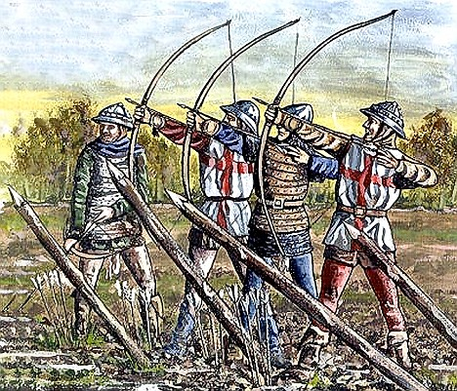

Source D - English Longbow men – Took seven years to train them and the arrows could pierce armour.

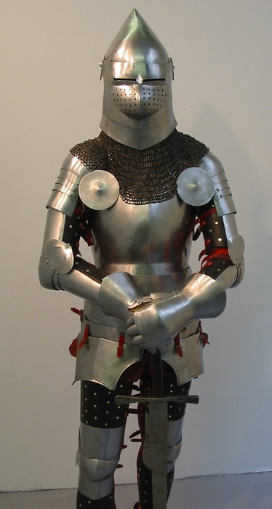

Source E – Plate armour from the period.