*Draw a picture about anything to do with the Plague*

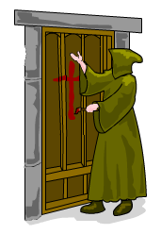



**BLACK DEATH DIARY**

**Dear Diary,**

**Today I am going to tell you about what is happening in England at the moment the year 1350.**

**Firstly, the black death has devastated my village__________________________________________________**

**_______________________________________________________________________________________**

**_______________________________________________________________________________________**

**People are suffering from this really bad illness known as the B_ _ _ _ _ D_ _ _ _ _, some of the symptoms are ____________________________________________________________________________________**

**_______________________________________________________________________________________**

**_______________________________________________________________________________________**

**_______________________________________________________________________________________**

**There is panic Europe as nobody knows what is causing the plague. There are lots of different theories of what is causing the plague some of these are _______________________________________________**

**_______________________________________________________________________________________**

**_______________________________________________________________________________________**

**People are trying to stop the plague by using different cures such as ______________________________________________________________________________________**

**_______________________________________________________________________________________**

**_______________________________________________________________________________________**

**_______________________________________________________________________________________**

**The plague has devastated Europe (explain how many people have died) _________________________**

**______________________________________________________________________________________**

**______________________________________________________________________________________**

**______________________________________________________________________________________**

**___________________________________________________________________________________**

**____________________________________________________________________________________**